Name: Muhammad Uzair

Roll No. L1F18BSCS0311

Section-H

Database

Lab 15 Part 1

Triggers

Q.1

(a)

create table customer (

acc_no int primary key,

cust_name varchar(20),

avail_balance decimal);

create table mini_statement (

last_update datetime,

acc_no int,

avail_balance decimal,

foreign key(acc_no) references customer(acc_no) on delete cascade);

insert into customer values (1000, "Fanny", 7000);

insert into customer values (1001, "Peter", 12000);

delimiter //

create trigger update_cus

before update

on

customer

for each row

begin

insert into mini_statement values (CURRENT_TIMESTAMP(),old.acc_no,old.avail_balance);

end;

//

Delimiter ;

update customer set avail_balance = avail_balance + 3000 where acc_no = 1001;

update customer set avail_balance = avail_balance + 3000 where acc_no = 1000;

select * from mini_statement;

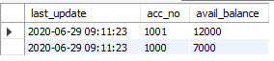

(b)

create table micro_statement (

last_update datetime,

acc_no int,

avail_balance decimal,

foreign key(acc_no) references customer(acc_no) on delete cascade);

insert into customer values (1002, "Janitor", 4500);

delimiter //

create trigger update_after

after update

on

customer

for each row

begin

insert into micro_statement values(CURRENT_TIMESTAMP(), new.acc_no,new.avail_balance);

end;

//

delimiter ;

update customer set avail_balance = avail_balance + 1500 where acc_no = 1002;

select * from micro_statement;



(c)

The difference between Before Update and After Update is that in before update, the trigger enacts before an update is invoked. If an update statement is written, this trigger will perform its actions before the update is implemented. In after update, the tigger enacts after an update is invoked. If an update statement is writeen, this trigger will perform its actions after that update statement has been executed.

Q.2

(a)

create table contacts (

contact_id INT (11) NOT NULL AUTO_INCREMENT,

last_name VARCHAR (20) NOT NULL,

first_name VARCHAR (25),

birthday DATE,

created_date DATE,

created_by VARCHAR(20),

CONSTRAINT contacts_pk PRIMARY KEY (contact_id));

delimiter //

create trigger contacts_before_insert

before insert

on

contacts

for each row

begin

DECLARE vUser varchar(50);

select USER() into vUser;

SET NEW.created_date = SYSDATE();

SET NEW.created_by = vUser;

end;

//

Delimiter ;

insert into contacts values (1, "Newton", "Enigma",str_to_date ("19-08-1999", "%d-%m-%Y"),str_to_date ("17-03-2018", "%d-%m-%Y"), "xyz");

select * from contacts;



(b)

create table contacts1 (

contact_id int (11) NOT NULL AUTO_INCREMENT,

last_name VARCHAR(30) NOT NULL,

first_name VARCHAR(25),

birthday DATE,

CONSTRAINT contacts_pk PRIMARY KEY (contact_id));

create table contacts1_audit (

contact_id integer,

created_date date,

created_by varchar (30));

delimiter //

create trigger contacts_after_insert

after insert

on

contacts1

for each row

begin

DECLARE vUser varchar(30);

SELECT USER() into vUser;

INSERT into contacts1_audit ( contact_id, created_date, created_by)

VALUES ( NEW.contact_id, SYSDATE(), vUser );

END;

//

insert into contacts1 values (1, "Asif", "Majeed",str_to_date("20-06-1999", "%d-%m-%Y"));

select * from contacts1_audit;



(c)

The difference between Before Insert and After Insert is that in before insert, the trigger is invoked before an insert statement is executed. This means that whenever we execute an insert statement, this trigger will perform its action before its execution. In after insert, the trigger is invoked after an insert statement has been executed. Whenever we right an insert statement, this trigger will be invoked after it has been executed.

Q.3

(a)

create table contacts (

contact_id int (11) NOT NULL AUTO_INCREMENT,

last_name VARCHAR (30) NOT NULL,

first_name VARCHAR (25),

birthday DATE,

created_date DATE,

created_by VARCHAR(30),

CONSTRAINT contacts_pk PRIMARY KEY (contact_id));

create table contacts_audit (

contact_id integer,

deleted_date date,

deleted_by varchar(20));

delimiter //

create trigger contacts_before_delete

before delete

on

contacts

for each row

begin

DECLARE vUser varchar(50);

SELECT USER() into vUser;

INSERT into contacts_audit ( contact_id, deleted_date, deleted_by)

VALUES ( OLD.contact_id, SYSDATE(), vUser );

end;

//

insert into contacts values (1, "Bond", "Ruskin",str_to_date ("19-08-1995", "%d-%m-%Y"),str_to_date ("27-04-2018", "%d-%m-%Y"), "xyz");

delete from contacts where last_name = "Bond";

select *from contacts_audit;



(b)

create table contacts (

contact_id int (11) NOT NULL AUTO_INCREMENT,

last_name VARCHAR (30) NOT NULL,

first_name VARCHAR (25),

birthday DATE,

created_date DATE,

created_by VARCHAR (30),

CONSTRAINT contacts_pk PRIMARY KEY (contact_id));

create table contacts_audit (

contact_id integer,

deleted_date date,

deleted_by varchar(20));

delimiter //

create trigger contacts_after_delete

after delete

on contacts

for each row

begin

DECLARE vUser varchar(50);

SELECT USER() into vUser;

INSERT into contacts_audit ( contact_id, deleted_date, deleted_by)

VALUES ( OLD.contact_id, SYSDATE(), vUser );

end;

//

insert into contacts values (1, "Newton", "Isaac",str_to_date ("19-08-1985", "%d-%m-%Y"),str_to_date ("23-07-2018", "%d-%m-%Y"), "xyz");

delete from contacts where first_name="Isaac";

select *from contacts_audit;



(c)

The difference between before delete and after delete is that in before delete, the trigger is invoked before a delete statement is implement. It performs its actions before the execution of a delete statement. In after delete, the trigger is invoked after a delete statement is implemented. It performs its actions after the execution of a delete statement.

Lab 15 Part 2

Views

Q.1

create view Sale as

select upper(employees.first_name), lower(employees.last_name)

from employees

inner join orders

on employees.id = orders.employee_id

inner join order_details

on orders.id = order_details.order_id

inner join products

on order_details.product_id = products.id and products.product_name like '%Northwind Traders Dried Pears%';

select * from Sale;

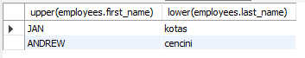

Q.2

Alter view Sale as

select employees.*, products.product_code

from employees

inner join orders

on employees.id = orders.employee_id

inner join order_details

on orders.id = order_details.order_id

inner join products

on order_details.product_id = products.id and products.product_name like '%Northwind Traders Dried Pears%';

select * from Sale;





Q.3

create view Customer_order as

select concat(first_name,' ',last_name) as Full_Name,

(select count(customer_id) from orders where orders.customer_id = customers.id and payment_type = 'Cash') as total_order_count

from customers

group by (id)

having total_order_count > 0;

select * from Customer_order;

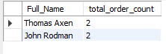

Q.4

Alter view Customer_order as

select concat(first_name,' ',last_name) as Full_Name,

(select count(customer_id) from orders where orders.customer_id = customers.id and payment_type = 'Check') as total_order_count

from customers

group by (id)

having total_order_count >= 0;

select * from Customer_order;

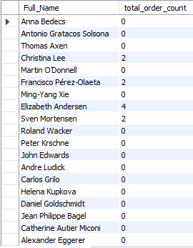

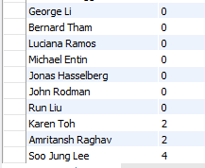

Q.5

create view Orders_view as

select id, order_date, (select status_name from orders_status where orders_status.id = status_id) as stats

from orders where exists

(select count(order_details.order_id) as different

from order_details

where orders.id = order_id

having different >= 3);

select * from Orders_view;

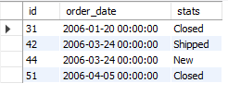

Q.6

Drop view Orders_view;



Q.7

create view Employee_purchase as

select concat(first_name,' ',last_name) as Employee_Name

from employees where id IN

(select employee_id from employee_privileges

where privilege_id IN

(select id from privileges where privilege_name = 'Purchase Approvals'));

select * from Employee_purchase;



Q.8

Alter view Employee_purchase as

select concat(first_name,' ',last_name) as Employee_Name

from employees where id IN

(select employee_id from employee_privileges

where privilege_id IN

(select id from privileges where privilege_name = 'Purchase Approvals'))

and employees.city = 'Redmond' or employees.city = 'Bellevue' or employees.city = 'kirkland';

select * from Employee_purchase;

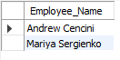

Q.9

create view Products_view as

select product_name, sum(unit_cost) as Amount

from products

inner join purchase_order_details

on products.id = product_id

group by(product_id);

select * from Products_view;

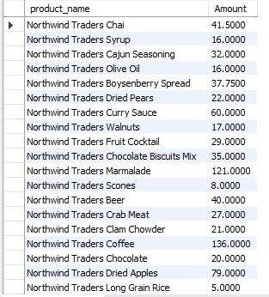

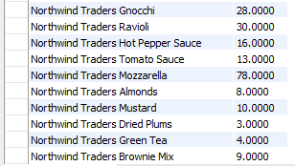

Q.10

ALter view Products_view as

select product_name, sum(unit_cost) as Amount

from products

left join purchase_order_details

on products.id = product_id

group by(product_id);

select * from Products_view;

